2026 ACBS World Conference Speaker Toolkit
Welcome to #ACBSWC26!
You have the unique opportunity to gain visibility for your commitment to advancing CBS and it’s practice through your speaking role at the 2026 ACBS World Conference! Your involvement contributes to furthering the collective mission to create a science that is more adequate to the challenges of the human condition.
This toolkit will provide ready-to-use social media graphics and post copy for you to maximize your reach.

Social Media Graphics
Below are branded graphics for you to choose from. (Right click to save)
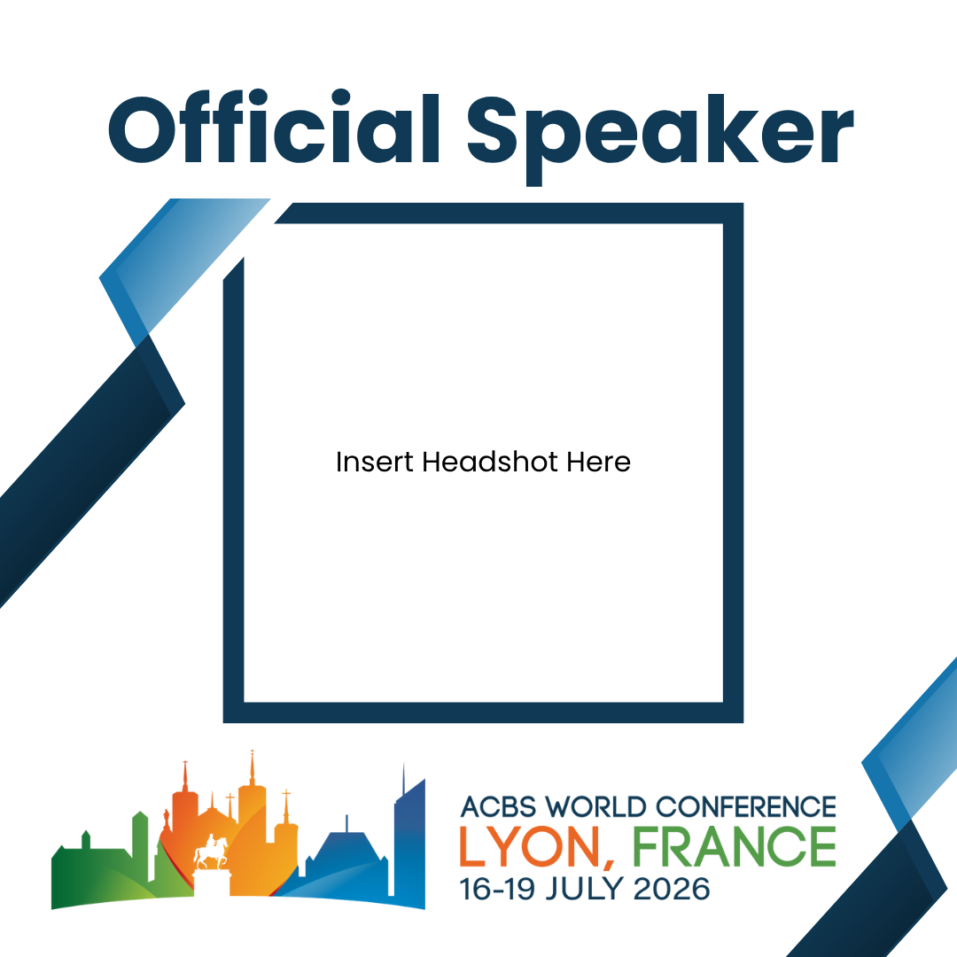
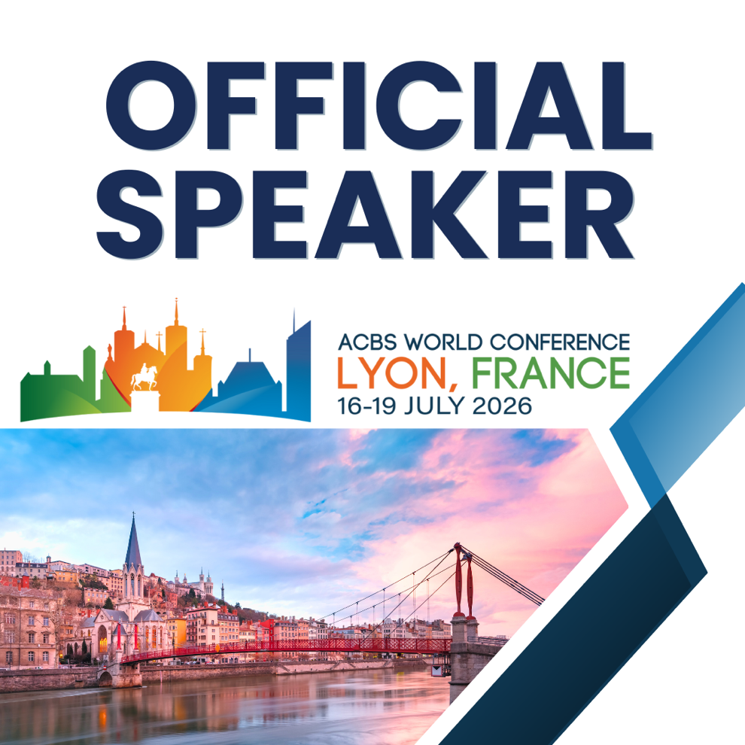
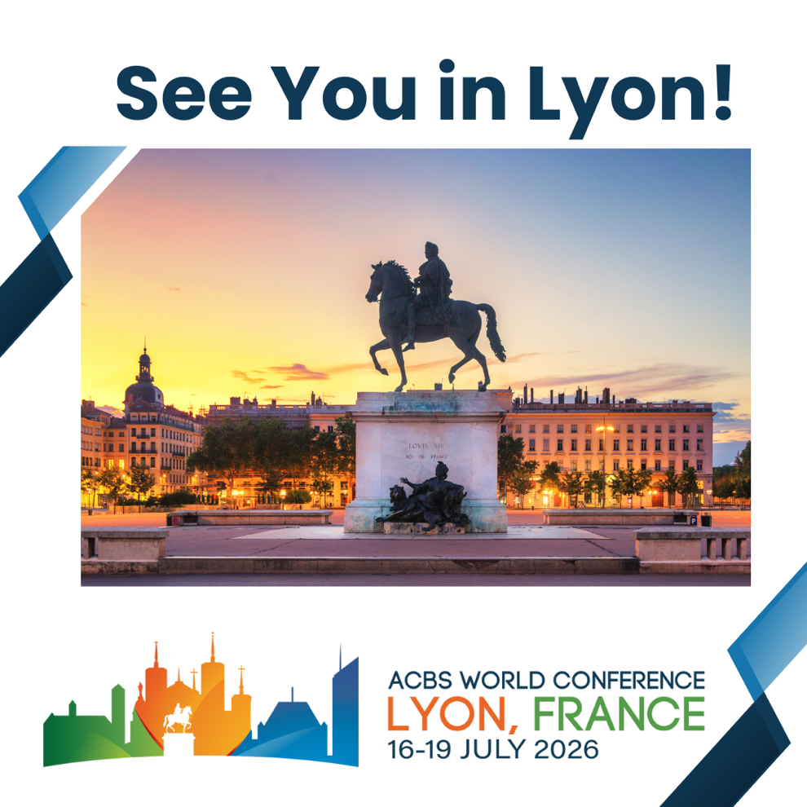
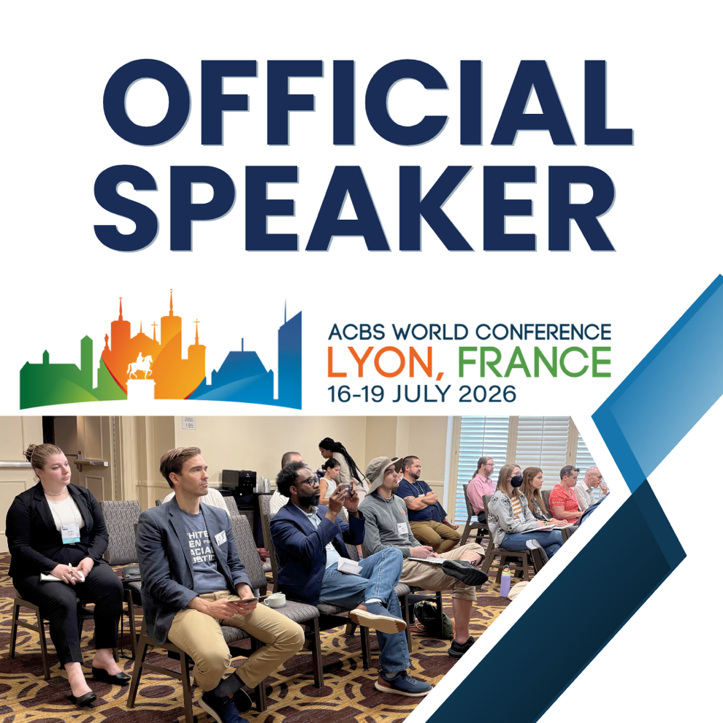

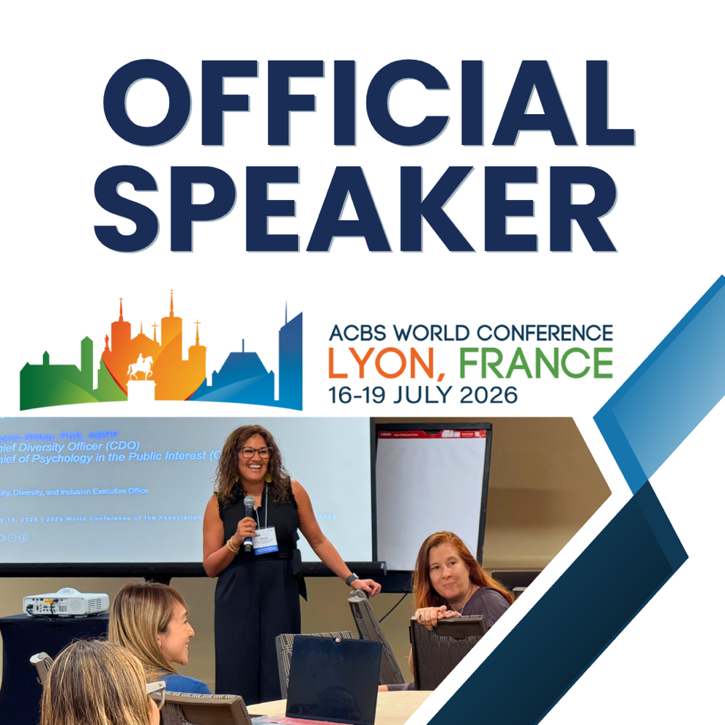

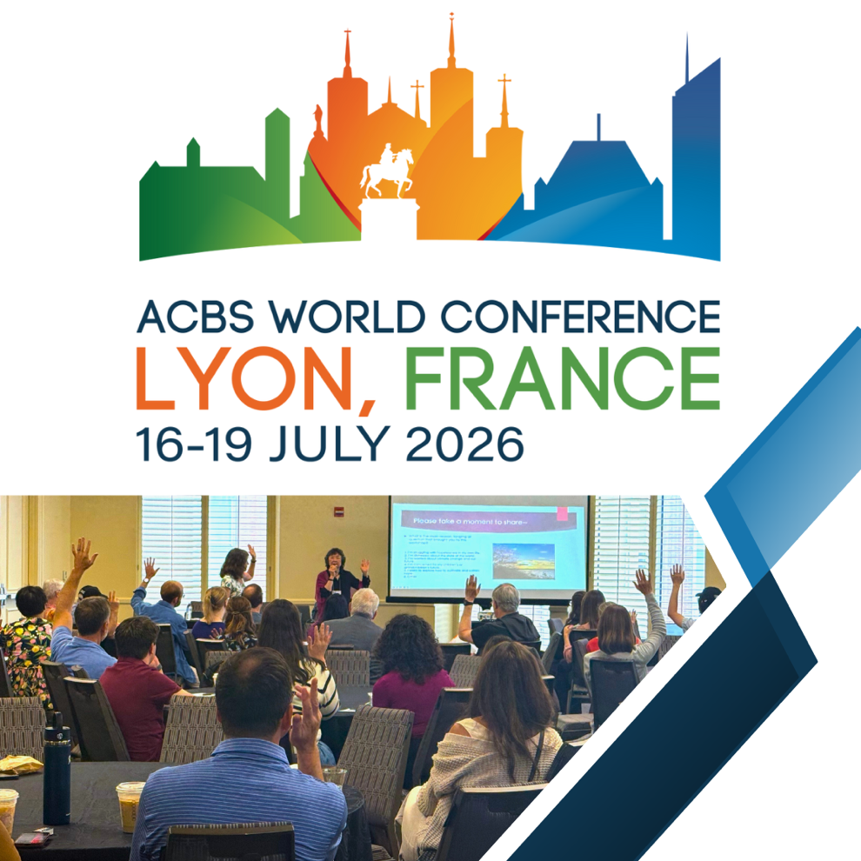

Social Media Copy
Below are examples of social media posts for you to use or customize as you see fit. Please remember to tag ACBS and use #ACBSWC26 #ACBS to assure that your posts are promoted among the global ACBS community. Feel free to edit and spice up as you see fit!
- Excited to be presenting in Lyon this July at the 2026 ACBS World Conference! Join me and colleagues from around the world for cutting-edge research, meaningful conversations, and new connections that move our field forward. https://bit.ly/3WM5AJn
#ACBS #ACBSWC26

- I’m excited to present [INSERT PRESENTATION TITLE] at the 2026 ACBS World Conference. Join us in Lyon this July! https://bit.ly/3WM5AJn #ACBS #ACBSWC26

- Join me this July in Lyon for the 2026 ACBS World Conference where science, practice, and community come together. Experience the latest in contextual behavioral science and connect with leaders shaping the future of our field. https://bit.ly/3WM5AJn
#ACBS #ACBSWC26

Email Signature
A one-liner in your email signature can be a quick and easy way to bring attention to your speaking role at #ACBSWC2026. Here are a couple of options—customizable, of course—to help you put in a plug for your upcoming session!
- I'm proud to be presenting at #ACBSWC26. Join me in Lyon, 16 – 19 July!
- I'm speaking! Join me and other inspiring industry leaders at #ACBSWC26 in Lyon, 16 – 19 July!
Option to add the conference logo to your signature as well using this link: https://bit.ly/4odmpJh
