Measuring Implicit Attitudes toward Auditory Verbal Hallucinations Using the Implicit Relational Assessment Procedure
Mirte Mellon¹
Annemieke Hendriks¹
Ciara McEnteggart²
Linde van Dongen¹
Gwenny Janssen¹
Yvonne Barnes-Holmes²
Jos Egger^{1,3,4}

1. Centre of Excellence for Neuropsychiatry, Vincent van Gogh Institute for Psychiatry, Venray, The Netherlands
2. National University of Ireland, Maynooth, Ireland
3. Behavioural Science Institute, Radboud University Nijmegen, Nijmegen, The Netherlands
4. Donders Institute for Brain, Cognition and Behaviour, Radboud University Nijmegen, Nijmegen, The Netherlands

Introduction
Auditory Verbal Hallucinations (AVHs) are experiences of hearing voices that occur in the absence of corresponding external speech. They are particularly common in schizophrenia patients but a substantial number of non-clinical, otherwise healthy individuals experience AVHs as well (e.g., Sommer et al., 2010). Clinical voice hearers experience their voices as being more negative and feel less in control of the voices as compared to non-clinical voice hearers (e.g., Honig et al., 1998).
Attitudes toward AVHs have traditionally been studied by means of self-report methods, such as interviews and questionnaires. In contrast, “implicit” methods such as the Implicit Relational Assessment Procedure (IRAP; Barnes-Holmes et al., 2006) may be used to measure implicit stimulus relations or implicit attitudes. The IRAP is derived from Relational Frame Theory (RFT; Hayes, Barnes-Holmes, & Roche, 2001).
The present study aims to examine the utility of the IRAP to point out differences in implicit attitudes toward Auditory Verbal Hallucinations (AVHs) between psychotic patients and non-clinical voice hearers. Therefore, the following question is addressed: do psychotic patients and non-clinical voice hearers produce different IRAP effects regarding emotional valence and perceived controllability of AVHs?

Method
Seven psychotic patients and eight non-clinical voice hearers completed two IRAPs—one concerning emotional valence and one concerning perceived controllability of AVHs. The emotional valence IRAP included trials concerning positive as well as negative emotional valence of AVHs. The controllability IRAP included trials concerning controllability and those concerning acceptance (as opposed to controllability) of AVHs. The trial content of both IRAPs was developed through extensive expert discussion. Participants were asked to respond as quickly as possible on statements according to a certain rule, which reversed several times. This implied that they sometimes needed to respond in a way that was consistent with their beliefs and sometimes in a way that was inconsistent with their beliefs. See Figure 1 for examples.

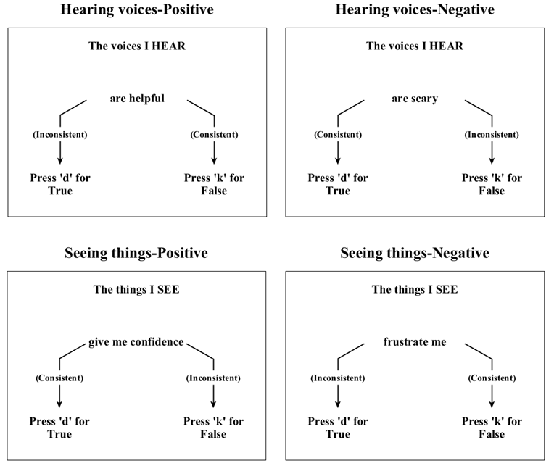
Figure 1. Examples of the four types of trials of the emotional valence IRAP. The arrows and text in brackets were not presented to participants in the actual IRAP.

The IRAP response latency scores were transformed into D-scores, which reflect standardized differences in response latencies between consistent and inconsistent blocks of trials (i.e., IRAP effects). The IRAP effects are assumed to provide information about participants’ previously established verbal relations and, as such, to reflect participants’ implicit attitudes and cognitions. With regard to the emotional valence IRAP, we tested if the D-scores for the hearing voices trial-type differed between the groups by means of a Mann-Whitney U-test. The group effect and (group x trial-type) interaction effect of the controllability IRAP were also tested using Mann-Whitney U-tests. Finally, one-sample Wilcoxon signed-rank tests were used to analyse if the IRAP effects for each group were statistically significant.

Results
Emotional valence IRAP
The mean D-scores for the hearing voices trial-type (see Figure 2) did not differ significantly between the groups (U₍₁₃₎ = 19.00, p = .336, effect size r = .289). Furthermore, the mean D-scores did not deviate significantly from zero for both the psychotic patients (p = .735) and the non-clinical voice hearers (p = .401).

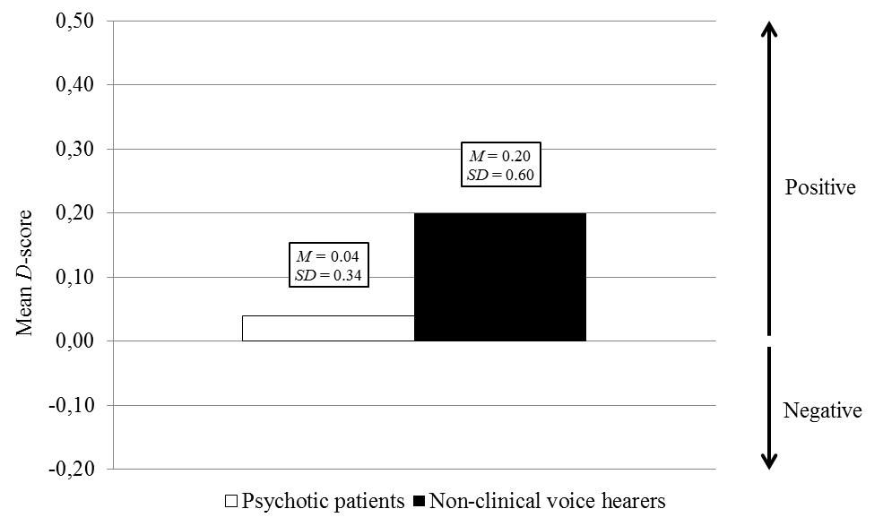
Figure 2. Mean D-scores, with standard deviations, for the hearing voices trial-type of the emotional valence IRAP for the psychotic patients and non-clinical voice hearers. A positive D-score reflects a positive attitude and a negative D-score reflects a negative attitude toward AVHs.
Controllability IRAP
For both groups, the mean D-scores for the pleasant voices trial-type and annoying voices trial-type are presented in Figure 3. A marginally significant group effect and (group x trial-type) interaction effect was found (both U₍₁₃₎ = 12.00, p = .072, effect size r = .478). When analysing the D-scores for each trial-type separately, a marginally significant difference between the groups was found for the pleasant voices trial-type (U₍₁₃₎ = 11.00, p = .054, effect size r = .508). One significant deviation from zero was found: the mean D-score for the non-clinical voice hearers for the pleasant voices trial-type (p = .036).
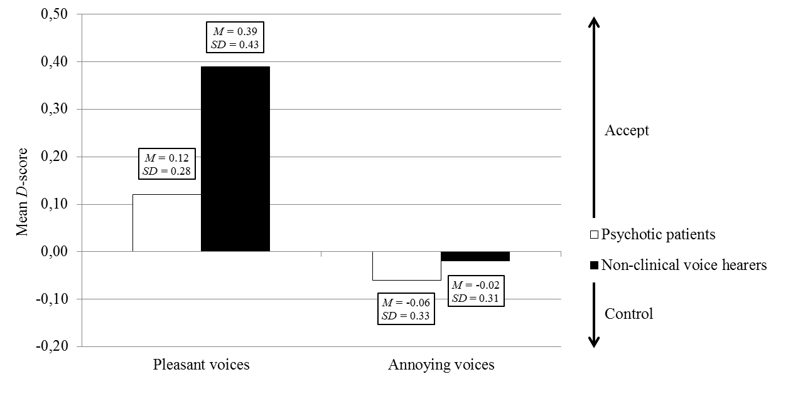
Figure 3. Mean D-scores, with standard deviations, for the pleasant voices trial-type and annoying voices trial-type of the controllability IRAP for the psychotic patients and non-clinical voice hearers. A positive D-score reflects an accepting attitude and a negative D-score reflects a controlling attitude toward AVHs.

In conclusion
- Psychotic patients and non-clinical voice hearers tend to produce a different IRAP effect regarding controllability of AVHs. These findings provide preliminary indications for the utility of the IRAP to point out differences in implicit attitudes between the groups.
- Psychotic patients and non-clinical voice hearers appear to relate stimuli to their voices in a similar (neutral) way and to have a comparable history of relational responding with respect to emotional valence.
- The groups seem to differ slightly in how they relate stimuli about acceptance and control to their pleasant voices, with a trend for acceptance (as opposed to control) for non-clinical voice hearers.
- “Explicit” and “implicit” methods seem to yield different results regarding attitudes toward AVHs. This might be due to the presence or absence of contextual factors. In terms of RFT, the IRAP captures an immediate relational response while self-reports involve further, elaborate responding that is more susceptible to contextual factors.

References
Barnes-Holmes, D., Barnes-Holmes, Y., Hayden, et al. (2006). Do you really know what you believe? Developing the Implicit Relational Assessment Procedure (IRAP) as a direct measure of implicit beliefs. Irish Psychologist, 32(7), 169-177.
Hayes, S. C., Barnes-Holmes, D., & Roche, B. (2001). Relational Frame Theory: A post-Skinnerian account of human language and cognition. New York: Plenum.
Honig, A., Romme, M. A., Ensink, B. J., et al. (1998). Auditory hallucinations: A comparison between patients and nonpatients. Journal of Nervous and Mental Disease, 186(10), 646-651.
Sommer, I. E., Daalman, K., Rietkerk, et al. (2010). Healthy individuals with auditory verbal hallucinations; who are they? Psychiatric assessments of a selected sample of 103 subjects. Schizophrenia Bulletin, 36(3), 633-641.

Correspondence
Mirte Mellon
Vincent van Gogh Institute for Psychiatry
Centre of Excellence for Neuropsychiatry
Stationsweg 46
5803 AC Venray, the Netherlands
Phone: +31 478 52 73 39
Fax: +31 478 52 76 26
E-mail: mmellon@vvgi.nl

